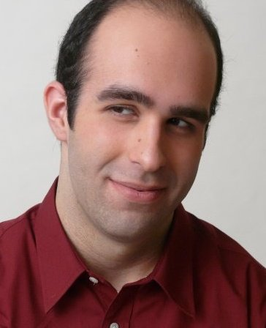
Anthony Castellano
(914) 572-8970
Calligman@aol.com

Hair Color: Dark Brown
Eye Color: Brown
Voice Type: Baritone/Tenor

Stage Credits
The Father | Pastor | Planet Connections Festival
It’s Only A Play | Ira Drew | Centerstage Community Playhouse
Nunsense A-Men! | Sister Hubert | Centerstage Community Playhouse
How to Succeed…. | Coffee Man/Ensemble | Congregation RodolphSholom
The Food Chain | Otto | Dix Hills Performing Arts Center
Sweet Charity | Herman | Dix Hills Performing Arts Center
Crazy For You | Moose | Dix Hills Performing Arts Center
Waiting For Lefty | Harry Fatt | Dix Hills Performing Arts Center
Company | Harry | Doorley Theatre
Uncle Vanya | Alexander Serebriokoff | Doorley Theatre
Taking Sides | Helmuth Rode | Doorley Theatre
Amadeus | Baron Van Sweiten | Doorley Theatre
She Love Me | Ensemble | SUNY Masquers

Children’s Theatre
Wiseacre Farm | O’connor | 13th Street Rep
Wizard of Oz | Oz | Dix Hills Performing Arts Center
Cinderella | Ensemble | Dix Hills Performing Arts Center
Honk Jr. | The Turkey | Dix Hills Performing Arts Center

Voice Over
Adventures of Hoot-Hoot | Grand Owl | Dix Hills Performing Arts Center

Independent Film
Campus Man | Brandon | Boanthropy Productions
The Good Samaritan | Teddy Berr | Dix Hills Performing Arts Center

Training
Acting Laura Wallace-Rhodes, Milton Justice, Kim Hubbard

Dance Phil Fabry, Lizbeth Lynn, Julie Preston

Voice Dan Radzikowski, Joshua Bailey, W. Brent Sawyer, William Demaniow,
Dr. Carrie Culver, Chuck Elliot

Special Skills: Piano Skills, German and English/British accent, Licensed Driver, Calligrapher

